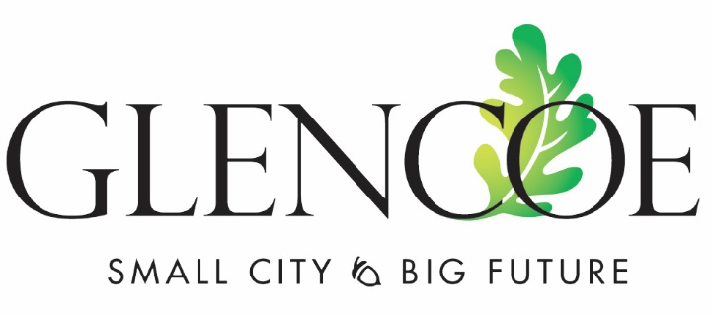
GLENCOE CITY COUNCIL MEETING MINUTES
October 31, 2022 – 7:00pm
City Center Ballroom

Attendees: Ryan Voss, Sue Olson, Allen Robeck, Cory Neid, Paul Lemke, Arnold Brinkmann
City Staff: City Administrator Mark Larson, Finance Director Todd Trippel, Public Works Director Jamie Voigt, City Attorney Mark Ostlund, Public Works Director Mark Lemen, Deputy City Clerk Kelly Hayes, Officer Taylor Bruns
Others: Mike Drew, LaRane Krueger, Rich Glennie, Lowell Anderson, Don Ide

- PLEDGE OF ALLEGIANCE AND MOMENT OF SILENCE

- CONSENT AGENDA
  - Approve Minutes of the Regular Meeting of October 17, 2022
  - Resolution 2022-025 Appointing General Election Judges Moved to 6A
  - Peddlers license Legacy Restoration
Motion: Robeck, seconded by Neid to approve the consent agenda. All in favor, motion carried.

- PUBLIC COMMENT (agenda items only)
Resident Don Ide thanked the council for making changes to the ATV Ordinance so it is more in line with the state and other cities.

- PUBLIC HEARINGS
Public Hearing on the ATV Ordinance Amendment
  - Second Reading Ordinance 617 – Amending the ATV Ordinance
The public hearing was opened by Mayor Voss at 7:03pm. There was no public comment.
Motion: Lemke, seconded by Neid to close the public hearing at 7:04pm. All in favor, motion carried.
Motion: Lemke, seconded by Neid to approve the Second Reading of Ordinance 617, Amending the ATV Ordinance. All in favor, motion carried.
- BIDS AND QUOTES
  - 2023 Health Insurance Renewal with Medica
The proposed increase for Medica is 8.25%. A cost comparison was completed with other insurances and Medica had the lowest increase.
Motion: Lemke, seconded by Olson to approve the 2023 Health Insurance Renewal with Medica. All in favor, motion carried.

  - 2023 Pavement Management Project – John Rodeberg, SEH
        - Supplemental Letter Agreement with SEH for 2023 Pavement Project
Motion: Neid, seconded by Olson to approve the Supplemental Letter Agreement with SEH for 2023 Pavement Project. All in favor, motion carried.

        - Resolution 2022-26 – Authorizing SEH to Prepare the Report for the 2023 Pavement Management Project
Motion: Lemke, seconded by Olson to approve Resolution 2022-26 – Authorizing SEH to Prepare the Report for the 2023 Pavement Management Project. Vote 4 – 1 with Robeck against, motion carried.

  - Airport Terminal Bid – Adinda Van Espen, SEH
        - Resolution 2022-27 – Approving Plans and Specifications for the Terminal Project at the Glencoe Airport (GYL) and setting a bid opening for November 22, 2022 at 10:00 AM.
Motion: Lemke, seconded by Brinkmann to approve Resolution 2022-27 – Approving Plans and Specifications for the Terminal Project at the Glencoe Airport (GYL) and setting a bid opening for November 22, 2022 at 10:00am. All in favor, motion carried.
  - Replacement of 2021 TOOLCAT – James Voigt, Public Works Director – Streets and Parks
Motion: Neid, seconded by Olson to approve replacement of 2021 TOOLCAT. All in favor, motion carried.

- REQUESTS TO BE HEARD
  - Resolution 2022-25 – Resolution Designating Election Judges for the 2023 General Election, November 8, 2022
Motion: Brinkmann, seconded by Neid to approve Resolution 2022-25 – Resolution Designating Election Judges for the 2023 General Election, November 8, 2022. All in favor, motion carried.

- ITEMS FOR DISCUSSION – None Scheduled

- ROUTINE BUSINESS
  - Project Updates - none
  - Economic Development - none
  - Public Input
Robeck received complaints about Bitcoin. Lemke checked the noise out and it was the grain bins that were making noise. Voss noted that there are things happening; the company has been working on the sound issues.
  - Reports
  - City Bills
Motion: Brinkmann, seconded by Neid to pay the city bills. All in favor, motion carried.

- ADJOURNMENT
Motion: Robeck, seconded by Neid to adjourn at 8:01pm. All in favor, motion carried.

___________________________________________ ___________________________________________
Ryan Voss, Mayor Mark Larson, City Administrator

