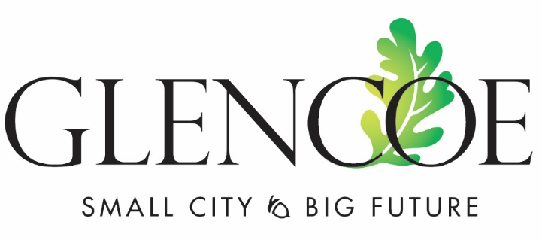
GLENCOE CITY COUNCIL MEETING MINUTES
December 19, 2022 – 7:00pm
City Center Ballroom

Attendees: Ryan Voss, Sue Olson, Allen Robeck, Cory Neid, Paul Lemke, Arnie Brinkmann
Absent: Cory Neid
City Staff: City Administrator Mark Larson, Finance Director Todd Trippel, City Attorney Mark Ostlund, Public Works Director Mark Lemen, Deputy City Clerk Kelly Hayes, Police Chief Tony Padilla, Public Works Director Jamie Voigt, Assistant City Administrator Jon Jerabek
Others: Rich Glennie, Mark Hueser, Mark Simons, Brody Bratsch, Justin Black

- PLEDGE OF ALLEGIANCE AND MOMENT OF SILENCE
Mayor Voss called the meeting to order at 7:00pm. Present: Ryan Voss, Sue Olson, Allen Robeck, Cory Neid, Paul Lemke, Arnie Brinkmann. Absent: Cory Neid

- CONSENT AGENDA
  - Approve Minutes of December 5, 2022, City Council Meeting
  - Approve Annual Permits and Licenses
Robeck did not agree with changing the charter from the December 5, 2022, meeting. He said that the vote was against the City Charter and MN Statutes. Mayor Voss asked Robeck if the minutes reflected the actual vote at the last meeting, Robeck said yes. Attorney Ostlund noted that the minutes are what is up for vote at this time.
Motion: Lemke, seconded by Olson to approve the consent agenda. Vote 3 – 1 with Robeck against. Motion carries.
  - Awards – Glencoe Police Department
Glencoe Police Department presented lifesaving awards to Officer Brianna Korson, Sergeant Brian Stiles and Glencoe Resident Mark Simons for actions taken on August 14, 2022, at Oak Leaf Park which involved saving the life of John Sukalski,

- PUBLIC COMMENT (agenda items only) - There was no public comment.

- PUBLIC HEARINGS
  - Presentation of 2023-27 Pavement Management Study – Brody Bratsch, SEH
- Resolution 2022 - 032 – Resolution receiving report and setting Public Hearing for January 17, 2023 at 7:00 PM
Motion: Brinkmann, seconded by Robeck to approve Resolution 2022 - 032 – Resolution receiving report and setting Public Hearing for January 17, 2023, at 7:00 PM. All in favor, motion carried.

- BIDS AND QUOTES – NONE SCHEDULED

- REQUESTS TO BE HEARD
  - Short Term Rental - Ordinance Number 619 – Second Reading, City Attorney Ostlund
Motion: Lemke, seconded by Brinkmann to approve the second reading of Ordinance 619 regarding Short Term Rental. Vote 3-0-1 with Olson abstaining. Motion carries.

  - Occupancy Regulations – Ordinance Number 620 – Third Reading, City Attorney Ostlund
Robeck requested to have the word “natural” removed. Robeck noted that he feels as though this ordinance takes away from the rights of a landlord.
Motion: Olson, seconded by Brinkmann to approve the third reading of Ordinance 620, Occupancy Regulations. Vote 3 - 1 with Robeck against. Motion carries.

  - 2023 General Fund Budget and Debt Service Levy – City Administrator
- Resolution 2022-030 – Levy Resolution
Motion: Lemke, seconded by Brinkmann to approve Resolution 2022-030 setting the 2023 General Fund Budget and Debt Service Levy. Vote 3 – 1 with Robeck against. Motion carries.

  - Decertification of Tax Increment District 18 – West Industrial Park – City Administrator
- Resolution 2022-031 – Resolution to Decertify TIF District
Motion: Olson, seconded by Lemke to approve Resolution 2022-031 – a Resolution to Decertify TIF District. All in favor, motion carries.

  - Establishing the 2023 Polling Place Resolution 2022-033 – City Clerk Kelly Hayes
Motion: Robeck, seconded by Lemke to approve Resolution 2022-033 Establishing the 2023 Polling Place. All in favor, motion carries.

  - 2023/2024 Police Union Contract
There were some discrepancies in language. This will be brought back to the council at the next meeting.

  - Assessment Contract with McLeod County – City Administrator
Motion: Robeck, seconded by Olson to approve Assessment Contract with McLeod County. All in favor, motion carries.

- ITEMS FOR DISCUSSION
  - 2022 Airport Terminal Project Status
Still waiting for federal grants to be finalized. Looking at what the sale process will be for the current airport building.

  - Board and Commission member openings for 2023 Organizational meeting
There are openings on all of the boards and commissions: Park, Cemetery, Library, Light & Power, Planning, Charter, Airport.

- ROUTINE BUSINESS
  - Project Updates - none
  - Economic Development – Hotel looking to break ground in January.
  - Public Input - none
  - Reports – The next City Council meeting will be on Tuesday, January 3, 2023 at 7:00pm.
  - City Bills
Motion: Lemke, seconded by Brinkmann to approve the city bills. All in favor, motion carries.

- ADJOURNMENT
Motion: Robeck, seconded by Brinkmann to adjourn at 7:58pm. All in favor, motion carries.

___________________________________________ ___________________________________________
Ryan Voss, Mayor Mark Larson, City Administrator

