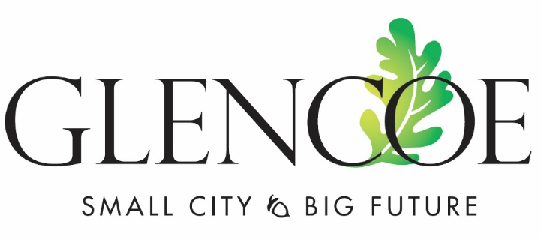

Ryan Voss

Sue Olson

Mark Hueser

Paul Lemke

Cory Neid

Yodee Rivera

Mayor:

Precinct 1 Councilor:

Precinct 2 Councilor:

Precinct 3 Councilor:

Precinct 4 Councilor:

At-Large Councilor:

**GLENCOE CITY COUNCIL MEETING AGENDA**

**August 21, 2023 – 7:00pm**

**City Center Ballroom**

1. **PLEDGE OF ALLEGIANCE AND MOMENT OF SILENCE**
2. **APPROVE THE AGENDA**
3. **CONSENT AGENDA**
   1. Approve City Council Minutes of August 7, 2023
   2. Approve Liquor Licenses: Casey’s on 10th St, Casey’s on 13th St, Glencoe Days (Security Bank)
   3. Special Event - Security Bank and Trust Block Party – August 29, 2023 – close 11th Street between Greeley Avenue and Hennepin Avenue
4. **PUBLIC COMMENT (agenda items only)**
5. **PUBLIC HEARINGS** 
   1. Reset Public Hearing on Alley Vacation of the East/West Alley in Lot 3, Block 40, Town of Franklin – City Administrator
   2. 7:00 PM - Public Hearing and Second Reading of the Ordinance 621 imposing a Moratorium on the Operation of a Cannabis Business in the City of Glencoe – City Attorney
   3. 7:00 PM - Public Hearing and Second Reading of Ordinance 622 prohibiting the use of Cannabis in Public Places or on Public Property - City Attorney
6. **BIDS AND QUOTES**
   1. Request for Additional Compensation due to Haul Route change – 2023 Pavement Project – Gary Harms, GMH Asphalt
   2. Sealcoat and Crack Repair Quotes – PW Director Voigt
7. **REQUESTS TO BE HEARD**
   1. Coalition of Greater MN Cities Legislative Update – Darrin Lee, CGMC
   2. Planning and Industrial Commission recommendation:
8. Approve GSC Condominium Plat for former Bus Garage located at 1203 12th Street East – Ryan Voss, RDV Companies.

1. Approve rezoning request for proposed Residential use of property zoned B-1 at 2020 9th Street East – Jon Halbert, representing Bill Halbert.
2. Approve Variance Request of Ella Hanson, 1511 15th Street East to build a front yard deck to encroach on the 30-foot front yard setback. Deck would reduce setback from 30-feet to 20-feet.
   1. Police Department Requests – Police Chief Padilla
3. Public Assembly and First Amendment Activity Policy
4. New Hire Uniform Allowance
5. Wage Incentive using Public Safety State Aid Funds
6. **ITEMS FOR DISCUSSION** 
   1. Oscar Olson Park Comprehensive Plan – Park Board Recommendation
7. **ROUTINE BUSINESS**
   1. Project Updates
   2. Economic Development
   3. Public Input
   4. Reports
   5. City Bills
   6. Close City Council Meeting to review Pending Litigation - City of Glencoe and International Union of Operating Engineers, Local 49, BMS Case No. 24PCE0137
8. **ADJOURNMENT**